Capture, Analyze, and Harden a Small Network
Diagram of the small network that I will controll and generate known traffic and capture it.
Creation of our 3 components: router, host1 and host2
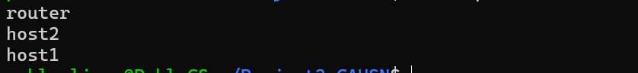
Creation of our veth pairs
Connected the hosts and router with their namespace
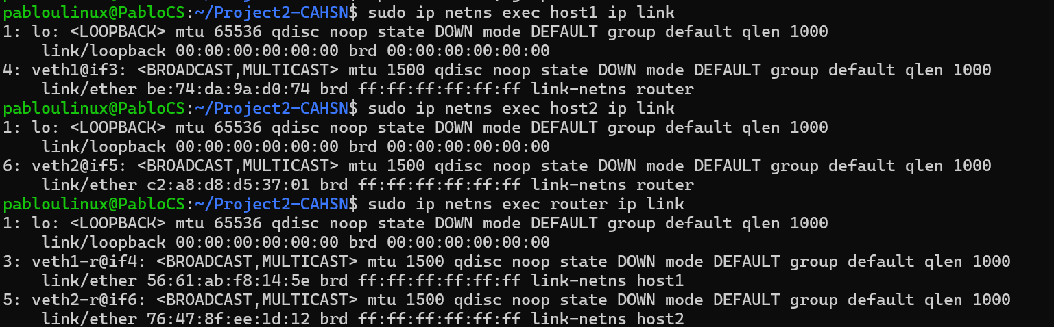
Ip address assignation
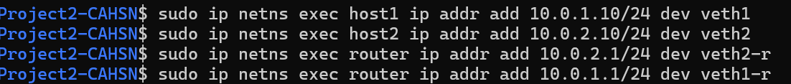
Bring everything up – For verification I did: sudo ip netns exec <namespace> ip a. Interface should say UP and show an IP
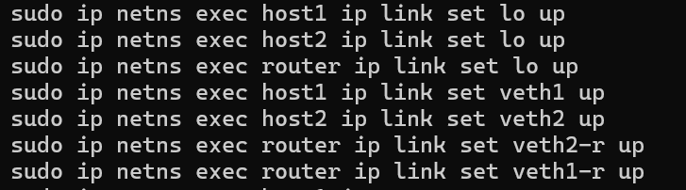
Enable the routing on the router. Reason is that Linux doesn’t forward packets between interfaces. Expected output: net.ipv4.ip_forward = 1.
Test Connectivity
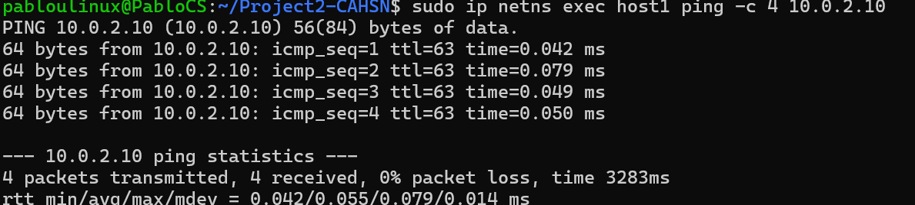
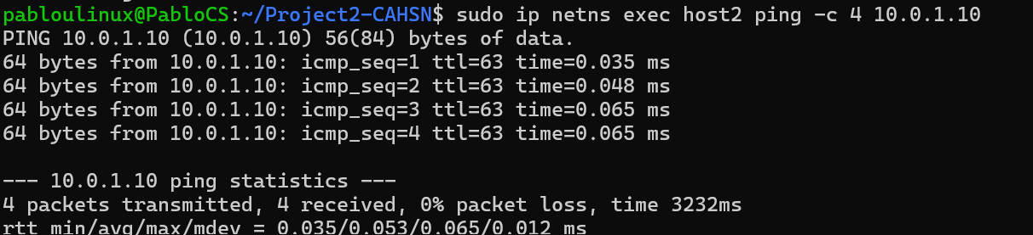
The lab has been successfully setup. Pinging for host works as well as cross-subnet from host1 host2 and reverse direction/
Look at ARP and routes:
:~/Project2-CAHSN$ sudo ip netns exec host1 arp -a
? (10.0.1.1) at 56:61:ab:f8:14:5e [ether] on veth1
~/Project2-CAHSN$ sudo ip netns exec host2 arp -a
? (10.0.2.1) at 76:47:8f:ee:1d:12 [ether] on veth2

FIRST CAPTURE OF TRAFFIC ON THE ROUTER
Need to create two terminals
First terminal: tcpdump action: sudo ip netns exec router tcpdump -i veth1-r -w lab.pcap -v
Second terminal: generate traffic: sudo ip netns exec host1 ping -c 8 10.0.2.10
First Terminal: CTR + C then wireshark lab.pcap
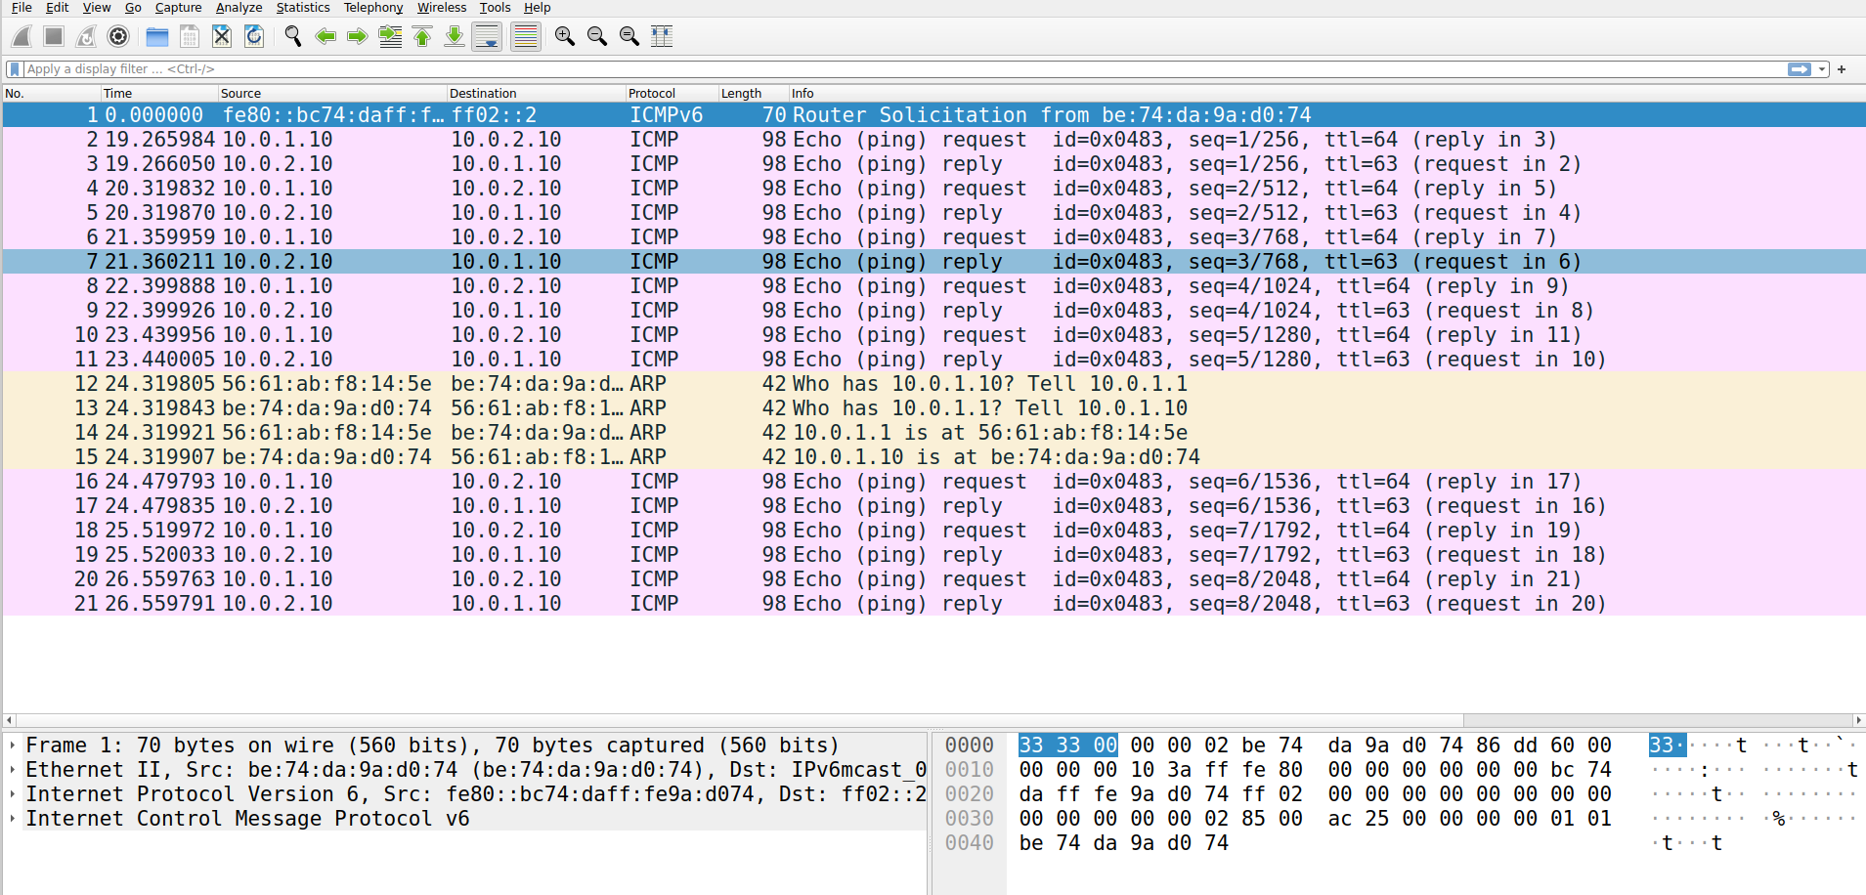
Capturing from the otherside
sudo ip netns exec router tcpdump -i veth2-r -w lab2.pcap -v
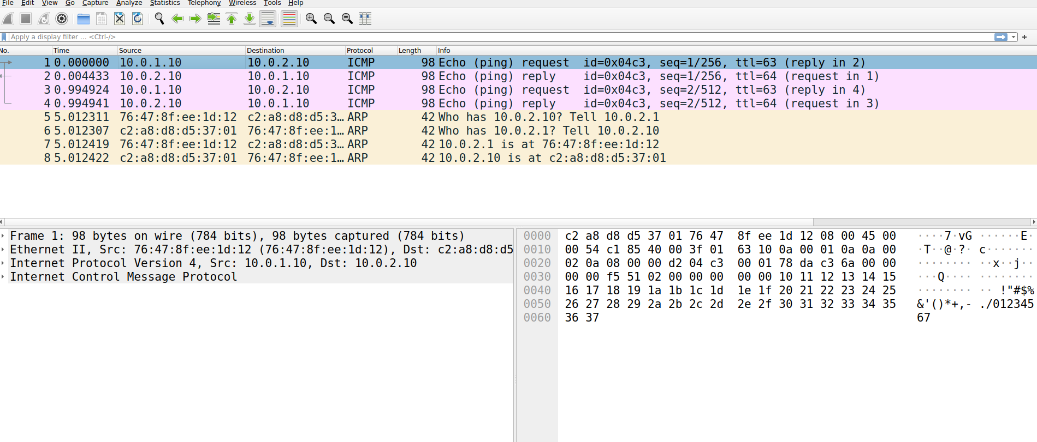
Comparing both lab1 and lab2 pcap ARP records:
Lab1 First ARP frame:
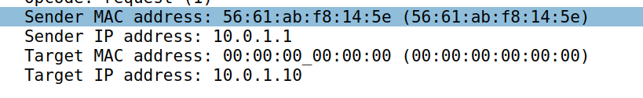
Lab 2 First ARP frame:
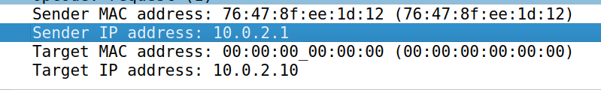
The difference between these two ARPs data is that on the first lab the Src MAC is from the veth1-r while on the lab2 is from veth2-r. Also the target IP address, lab1 is going for host1 and lab2 is targeting host2
Also when looking at the second ARP frames from both labs we can see that ARP is per-subnet, per-hop, and router initiated on each site it forwards onto. Exactly what should happen.

SCAN from host1 with nmap
First run a web server in host2 and verify it is working
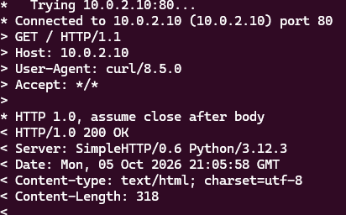
first terminal: 10.0.1.10 - - [05/Oct/2026 15:05:58] "GET / HTTP/1.1" 200 –
Now after getting ready the web server started to do nmap.
In terminal 3: Did 3 different nmap code executes using host1.
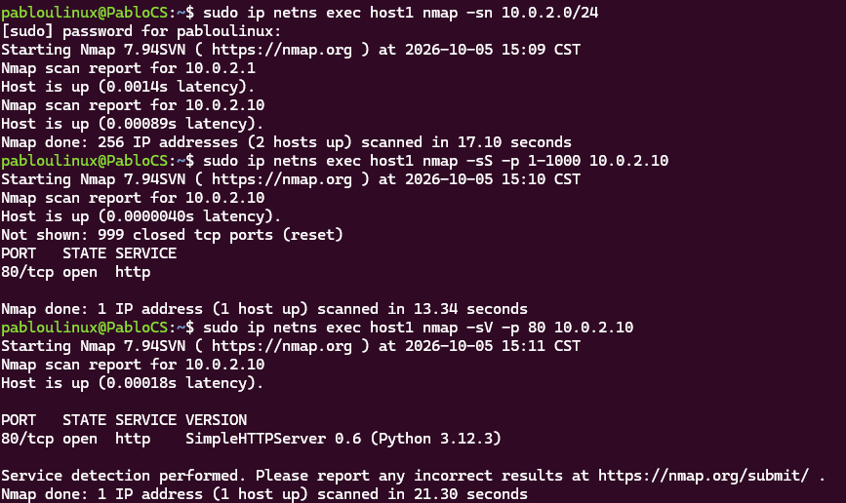
In terminal 2:
In terminal 1:
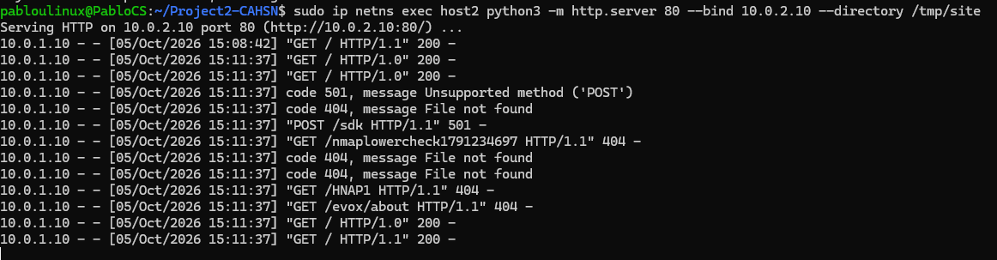
For each command that happened in terminal 3. Starting with the first command
sudo ip netns exec host1 nmap -sn 10.0.2.0/24 we are looking for pings from host1 to the IP 10.0.2.0/24.
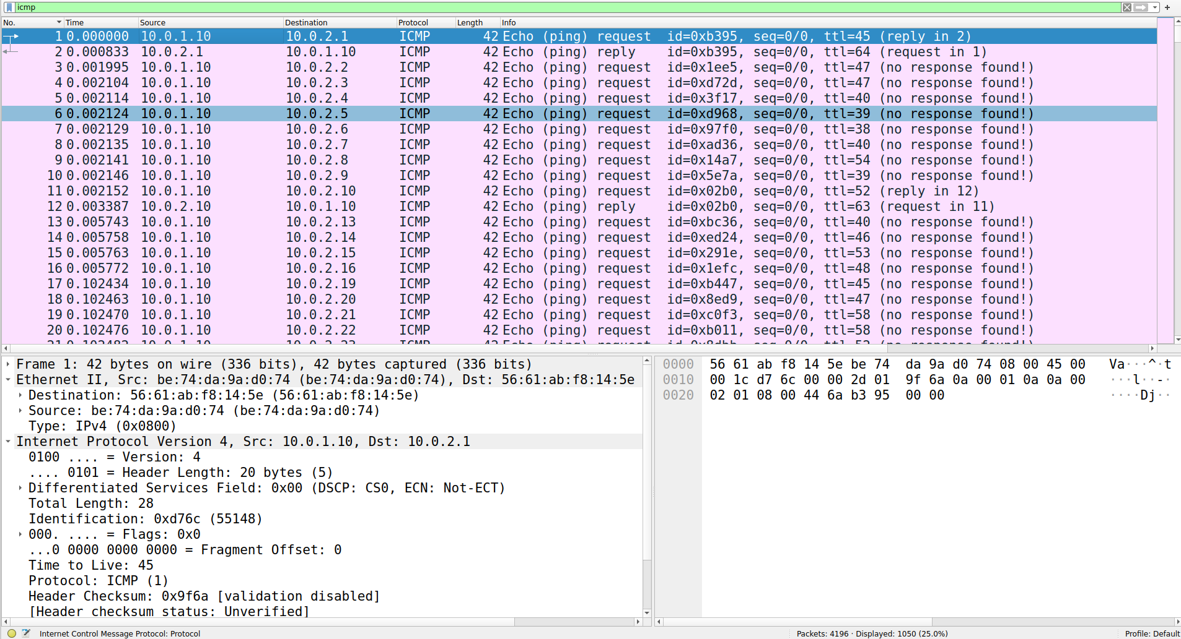

Next command that was used was: sudo ip netns exec host1 nmap -sS -p 1-1000 10.0.2.10 in here what we did was to use a scan technique, -sS/sT/sA/sW/sM: TCP SYN/Connect()/ACK/Window/Maimon scans, so what I’m looking for is tcp connection as well as to look on what port was opened from the 1-1000 range. From our terminal 3 window we had a message: “80/tcp open http” Now we know what we are looking for in wireshark.
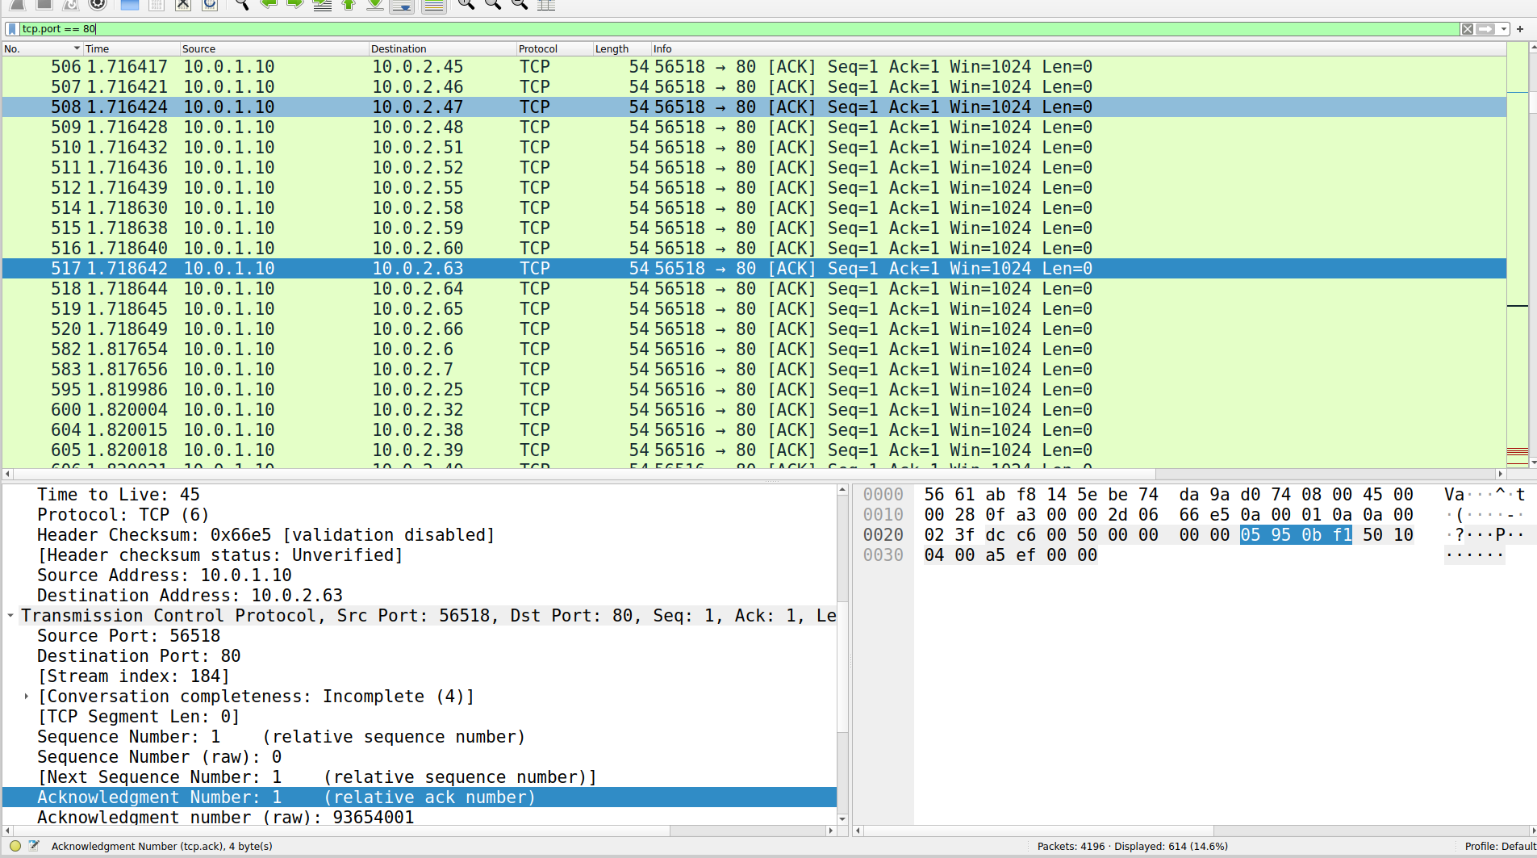
Lastly for the last command: sudo ip netns exec host1 nmap -sV -p 80 10.0.2.10 I am using a different tool for Service/Version detections that does the following: -sV: Probe open ports to determine service/version info. To look for more specific information, we should be look in the terminal window and check the output: “80/tcp open http SimpleHTTPServer 0.6 (Python 3.12.3)” We know is using the tcp protocol in the port 80 and lastly we have the SimpleHTTPServer 0.6. Those are our keywords to look for in the wireshark.
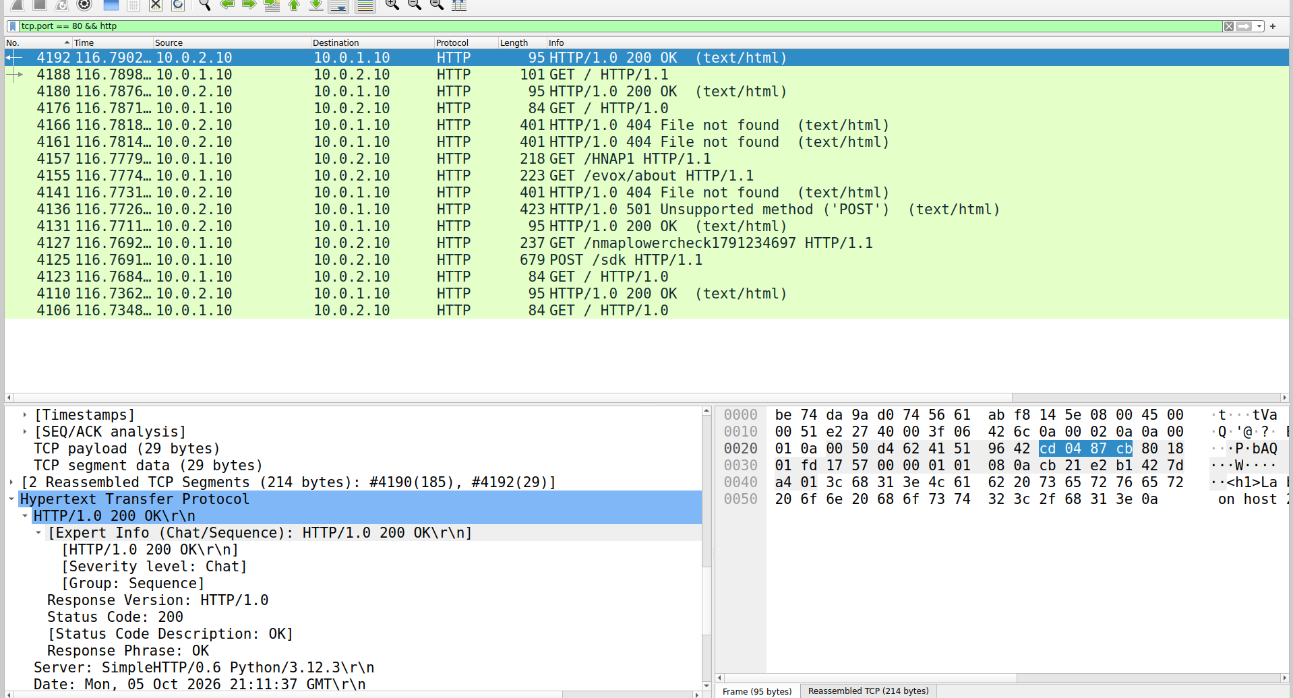
There were more of 4000 frames recorded, some interesting frame found was when doing the second command on the 3-way handshake.
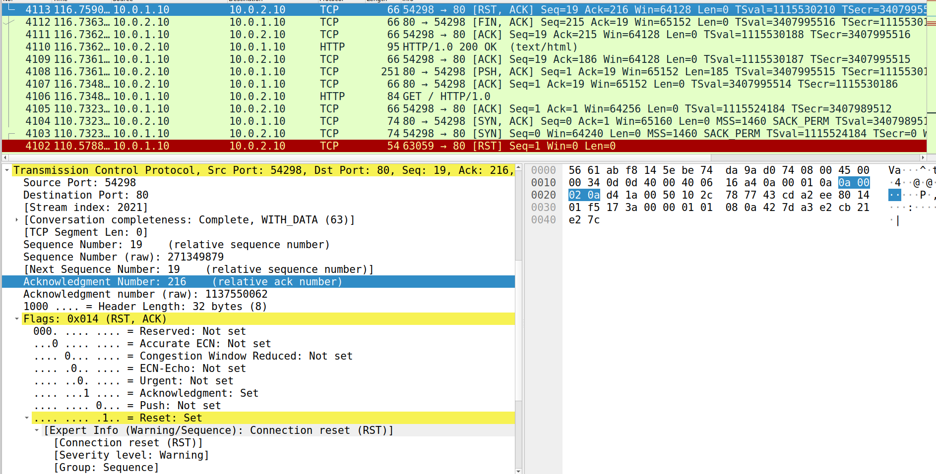
What is happening here is that there was a Reset on the TCP 3-way handshake, where in this specific frame the part from where the handshake was resetted was after the handshake was completed. After both SYN and ACK equaled to 1. What happened exactly was that the client (host1) finished but decided it doesn't want the connection anymore, and sent an RST to tear it down. This is exactly what nmap -sV does after grabbing the service banner, and what some HTTP clients do when they don't bother reading the full response body.

Addition of an attacker into our perfect environment
We need to create an attacker namespace, create its veth pair and configuration inside our ecosystem
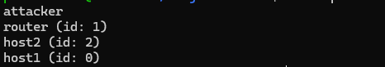
Verify connection:
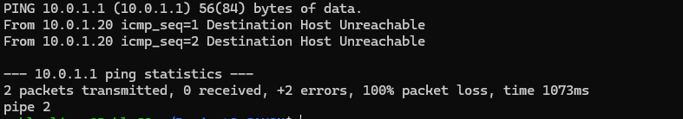
Getting error when pinging to the attacker ip.
Will run the following configuration to see what could be the issue:
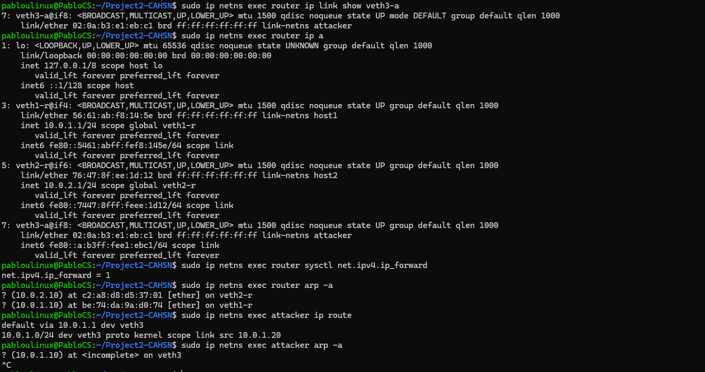
After close examination of what exactly could be the problem we can see that the issue is when the arp comes. This means that the router hasn’t learned the attacker’s MAC yet.
After a closer look we actually see the problem, veth3-a is up [in green line] and it has a MAC address: 02:0a:b3:e1:eb:c1.
What needs to be done is the building the bridge inside the router namespace.
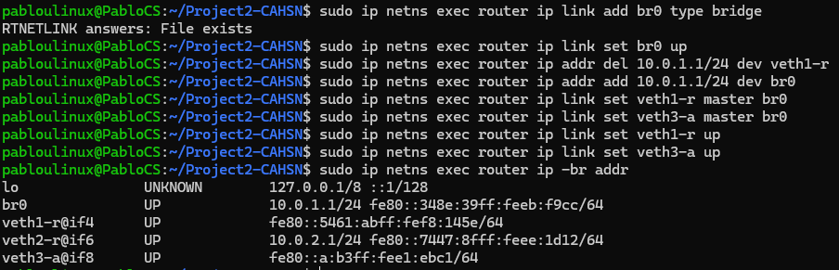
What happened here was that there was a bridge (br0) created in order for the attacker to be able to have access or do its role in the environment. As seen in br0, inherited 34:8e:39:eb:f9:cc, which now that is the gateway MAC for the 10.0.1.0/24 segment, and veth1-r old mac is gone from the router.
Now lets try one more time the pinging:
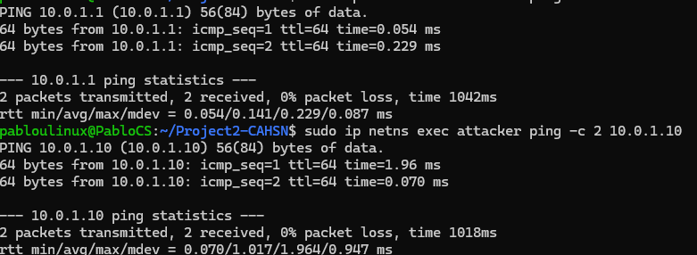
Now the host is reachable and there is no routing issu.
Checking the MAC from both host1 and attacker:
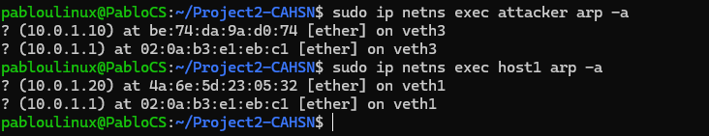

Today’s Date: 10/22/2026
Why I put the date? The reason was that after doing the last part which was checking the host1, attacker mac I got the terminal to shutdown by accident, and how I am still in university I got caught up in other stuff which made me forget about this project. Hence returning, I created with the help of AI an sh to rebuild the lab. The way that I did it was the following. First check my history and see from the checkpoint of where I started the project2 all the way to the latest thing. With help of AI I was able to create an .sh file that helped me rebuild the lab topology.
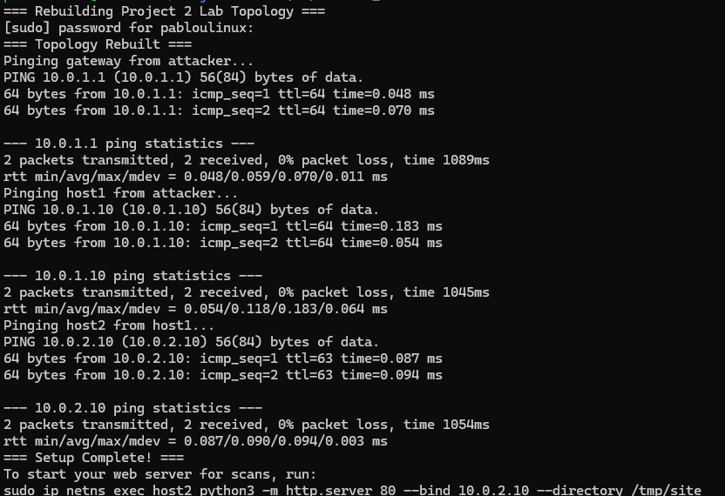

Now going back to where I left off was right before doing the scanning of the attacker in my perfect network topology.
We are going to be using 4 terminals.
The1st terminal: Start web server
The 2nd terminal: Start the capture for me to check later on Wireshark
The3rd terminal: Run the “poison” use arpspoof.
The 4th terminal: Watch the attack
What is arpspoof? In the SMM (System manager’s manual), it redirects packets from a target host on the LAN intended for another host on the LAN by forging ARP replies.

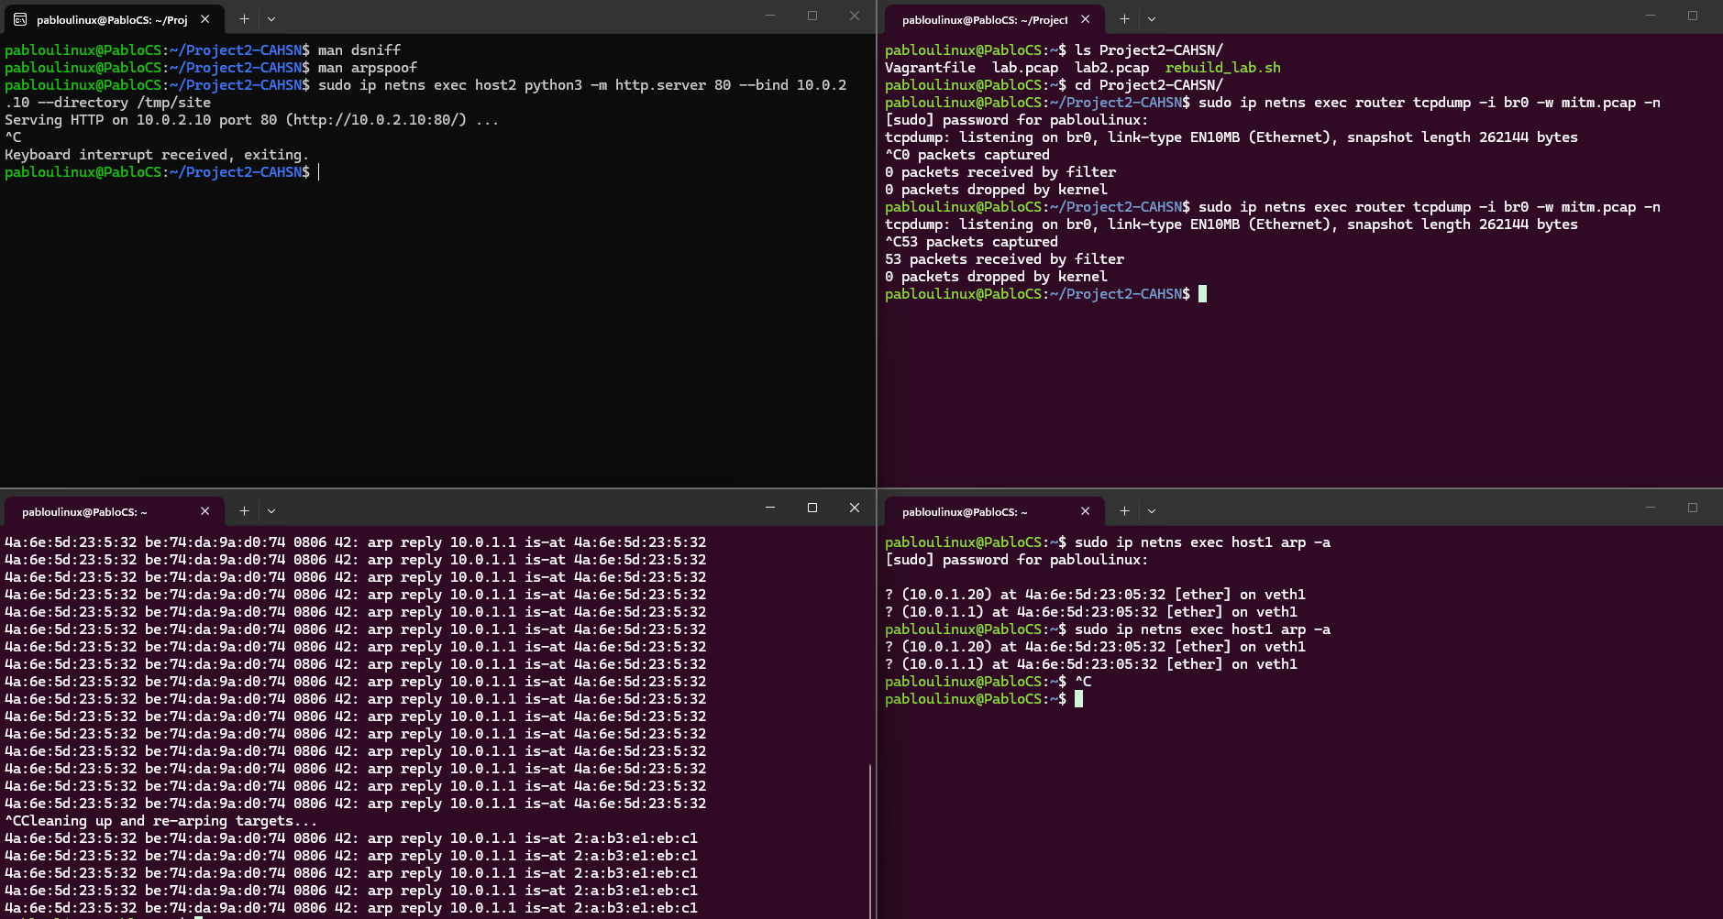

Now that we have finally done all 4 things, we are going with the next step.
How we know it worked?
First in the second terminal (where it says 2 and I know it looks small) we can see that there were 53 packets recorded, on our 3rd terminal we can see the arpspoof working as it says: “4a:6e:5d:23:5:32 be:74:da:9a:d0:74 0806 42: arp reply 10.0.1.1 is-at 4a:6e:5d:23:5:32” Lastly in the 4th terminal where we are looking at the connections of arps from our host1, it be can seen the MAC address from host1 changed to the attackers.

Now we will make this environment into a true MITM, where traffic actually flows, rather than juts breaking the network. The I will be implementing the firewall hardening
The following steps into our 4 terminals are the following:
The1st terminal: Enable forwarding on the attack
The 2nd terminal: Start the attacker’s sniffer
The 3rd terminal: Re-run the “poison” using arpspoof
The 4th terminal: Generate traffic from host 1

Evidence that worked: Looking at terminal 2 here we will see raw HTTP Get request and the html response in plain text flowing through the attacker
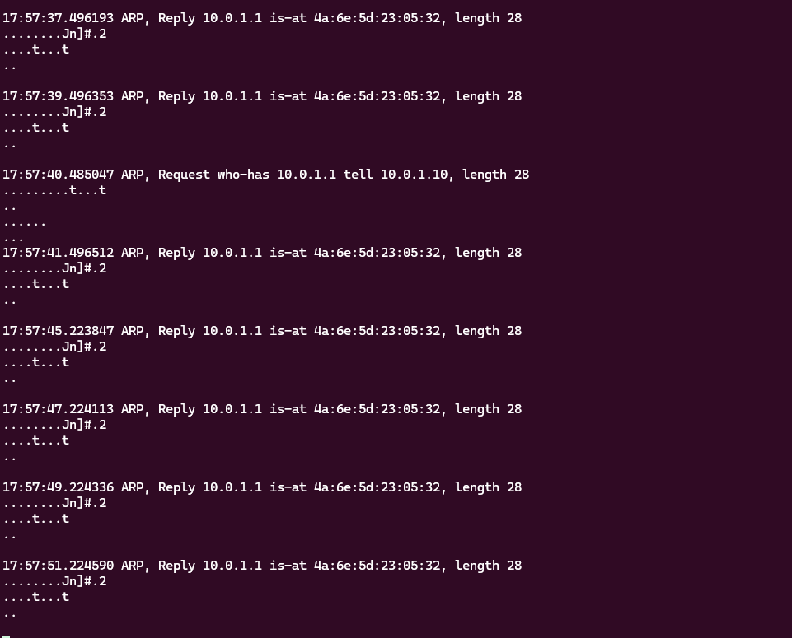

Now going with the Firewall Hardening:
Before doing the rule 1 using iptables I decided to do some research about firewall in linux. In the end I found 4 differente ways to do the same job, of course each one is more suitable for a different scenario/context.
Starting with nftables. It is the modern backend engine, it was built into the linux kernel to replace iptables infrastructure, it is faster, handles IPv4 and IPv6 simultaneously and uses less CPU. As a result, for simple laptops with not much hardware and for today’s world is a very good option.
Iptables. This command is also a low-level engine like nftables, but it is the legacu backend. From reading a bit more, iptables in moden Ubuntu versions it translates to nftables rules behind the scenes using a compatibility layer called iptables-nft. Hence it using in the end nftables backend engine.
ufw. The biggest difference from ufw with nftables and iptables is that it is Ubuntu’s defaulthigh-level frontend. It is designed to make complex backend rules human-readable, it translates simple commands like ufw allow 22 into complex backend rules
firewalld. This is Red Hat’s alternative high-level frontend. Need to install it on Ubuntu and its design is used as zones, such as public, home and etc, to manage traffic dynamically without restarting the firewall.

After learning and all, I am going to use nftables as this is much more efficient and is just the best for this simple case scenario.
Before actually doing the rules, I need to create the table and chain.
Using the following commands:
sudo ip netns exec router nft add table ip filter
sudo ip netns exec router nft add chain ip filter FORWARD '{ type filter hook forward priority 0; policy accept; }'
I will be creating a filter table for IPV4 and create a forward chain attached to the packet forwarding hook. Also in the part of between the ‘ ‘ what I am doing is making the policy accept means the default is allow all, then I will be adding the specific rules.
The following rules I need to add:
Rule 1: Stateful return traffic – allow established/related
Rule 2: Allow HTTP to host2
Rule 3: Default Deny for host2
To verify all three rules are in placed: sudo ip netns exec router nft list tables
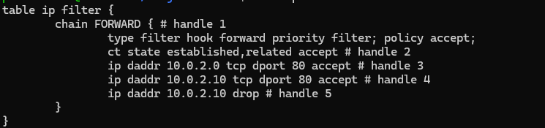
Here are the current rules, as shown in the image, there is an extra rule added for the 10.0.2.0, which wasn’t meant to be added. So I’m going to delete that with its name called handle 3
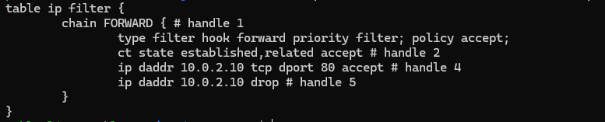
There all done now I have my 3 rules.
Now testing comes.
Test A: HTTP should succeed (allowed by Rule 2 + 1)
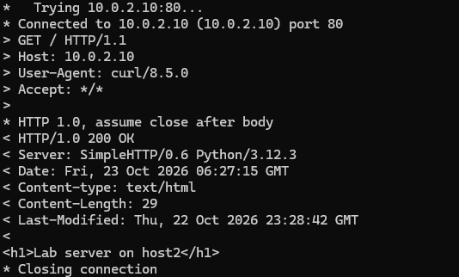
Mission success.
Test B: Ping host2.
The prediction in this test should be fail or something like couldn’t connect to server or fail connection
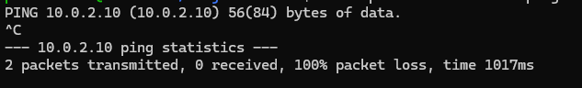
Mission success, we can see that there were 2 packets transmitted with 100% packet loss
Test C: Check the packet counters.
From learning more about nft command library, the output is different. It shows counters clearly but in a different format. Apparently, in the first try I was only getting this output:
table ip filter {
chain FORWARD {
type filter hook forward priority filter; policy accept;
ct state established,related accept
ip daddr 10.0.2.10 tcp dport 80 accept
ip daddr 10.0.2.10 drop
}
}

The reason for this is because I need to explicitly say in the rule to show the counter, hence the new rules just needed to add at the end counter accept. After doing that and redoing both tests here are the results:
table ip filter {
chain FORWARD {
type filter hook forward priority filter; policy accept;
ct state established,related counter packets 12 bytes 918 accept
ip daddr 10.0.2.10 tcp dport 80 counter packets 1 bytes 60 accept
ip daddr 10.0.2.10 counter packets 2 bytes 168 drop
}
}
Now we can see the packets, and how many were accepted or dropped.a

